Title: Introduction to Assembly

Group Name: Minios

Lab 02

**1. Start the simulator.**

We started by invoking MarieSim using the executable JAR file, by double clicking on the MarieSim JAR icon.

**2. Invoke the code editor.**

From the [File] menu on the menu bar, we select [Edit]

**3. Enter the program source code.**

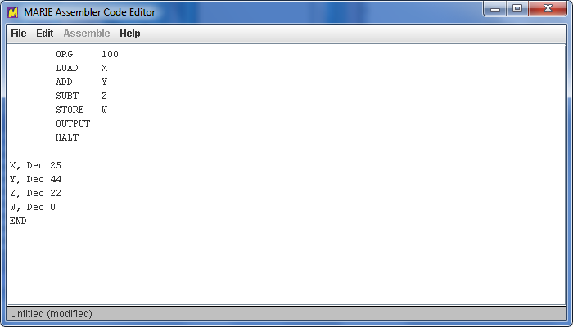

**4. Assemble**

Then we saved the program and clicked the assemble button

At the button it shows that it works by stating that the Assembly is successful

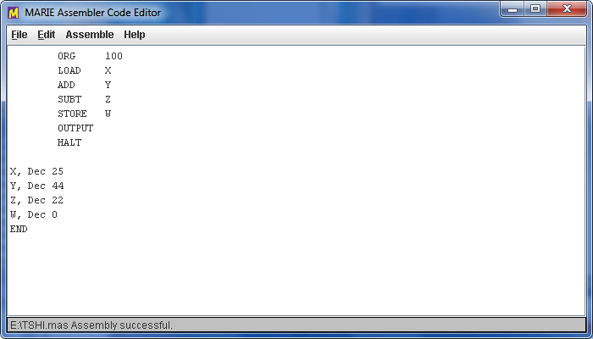

**5. Load the program.**

From the main simulator pane select [Load] from the [File] menubar option.

The file dialog pops up, showing that all of the MARIE executable files (.mex) files in the current directory.

**6. Run the program.**

We selected the run mode options from the [Run] menu as shown below

The output is displayed in the output box.

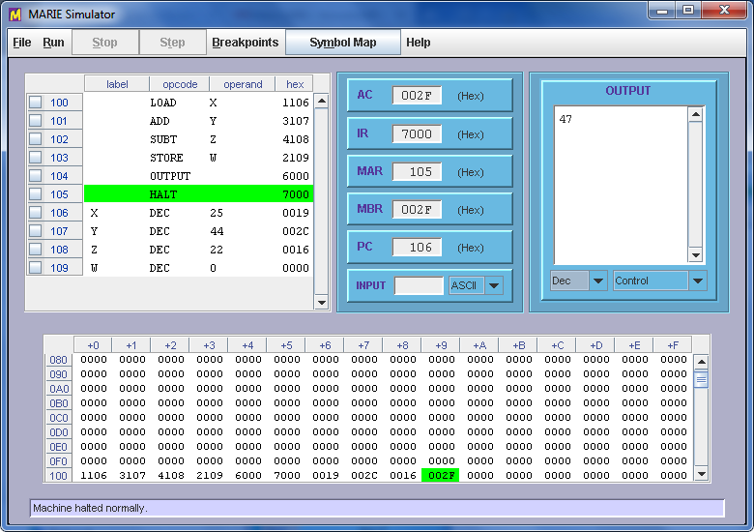

**7. Start the data path simulator**

We started by invoking Data path Simulator using the executable Dip file, by double clicking on the MarieDIP.Jar icon.

**8. Invoke the code editor.**

From the [File] menu on the menu bar, we select [Load]

**9. Enter the program source code.**

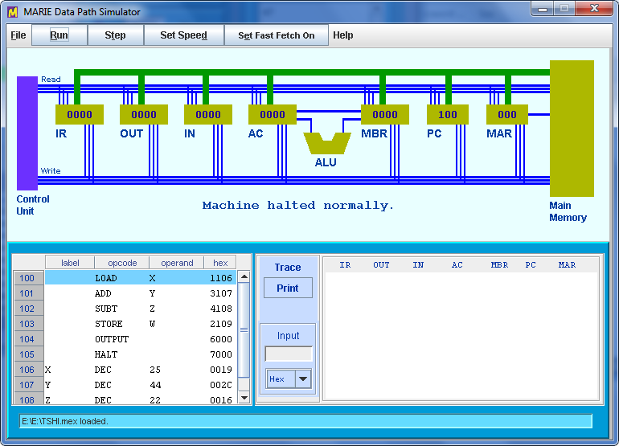

**10. Run the program.**

We selected the run mode options from the [Run] menu as shown below

